
IT Helpdesk  Jönköping University |  | Manual  Skapad av Aletom  Senast ändrad [2026-03-11]

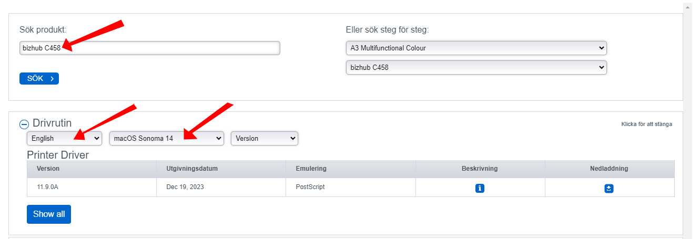
Download the driver package from Konica Minolta’s website:
https://www.konicaminolta.se/sv-se/service-support/download-centre

Search for Bizhub C458 and select Language: English, then choose your OS version.

Download the installation file that appears.

Double-click the downloaded .dmg file so it mounts (it usually ends up on the desktop).
Open the folder and double-click the file C759_C658_C368_C287_C3851_109.pkg.
Approve the installation using your local user account and follow the steps by clicking Next and accepting the terms, then continue with Next, Install, etc.
PS: You must be connected to Eduroam to be able to reach the printer.

Öppna sedan Inställningar och gå in välj Skrivare & Skanners.

Open System Settings and go to Printers & Scanners.
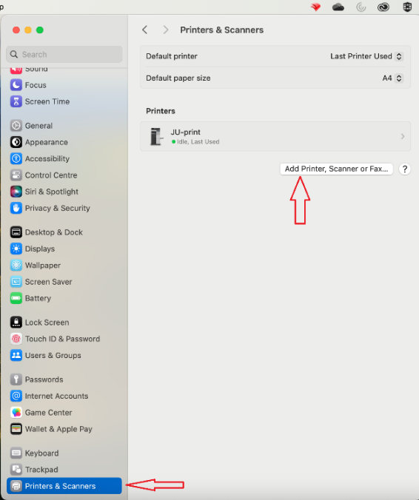
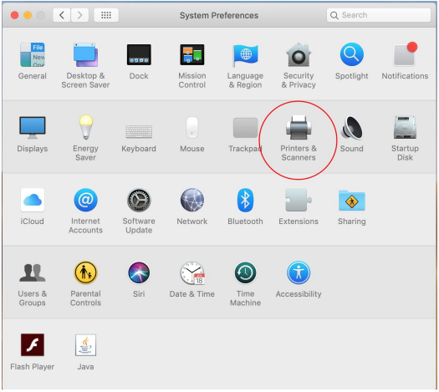

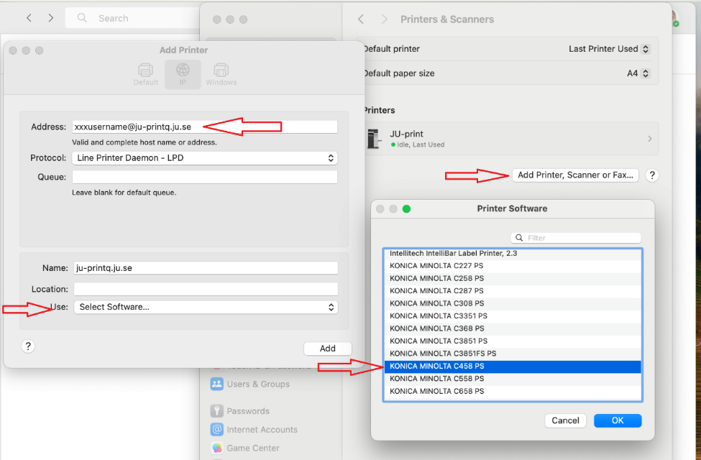
Enter the address xxxx24xx@ju-printq.ju.se, where you replace xxxx24xx with your JU username.
Under Protocol, choose Line Printer Daemon – LPD.

Where it says Generic PostScript Printer, instead choose Select Software.
Select KONICA MINOLTA C458 PS from the list and click OK.
Set the following options:
- Paper Source Unit: PC-415
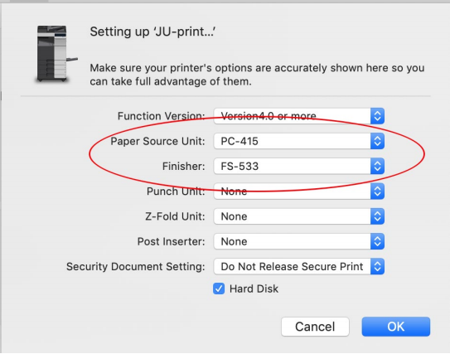
- Finisher: FS-533

Click OK. You should now be able to select this printer when printing.

