

- Dialogue between doctoral student and supervisory team

Guidelines for annual follow-up meeting in third-cycle education
CREATED BY Anna Bjällmark and Jan Mårtensson

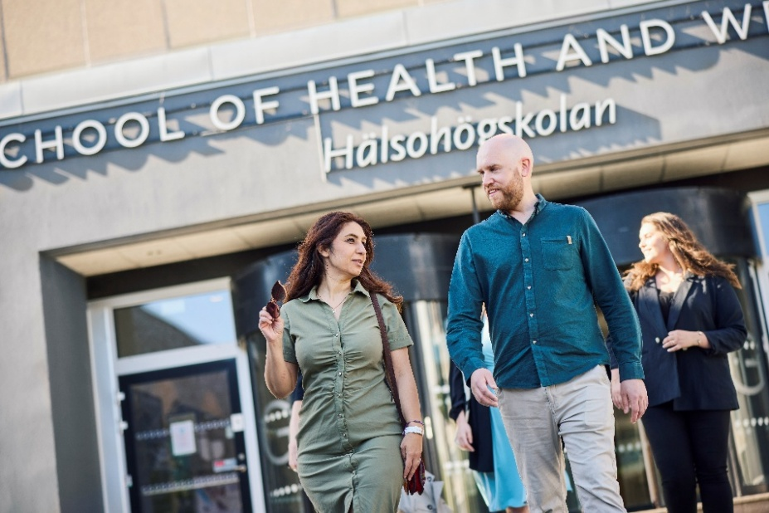

This guideline has been developed as a support for the annual follow-up meeting between the doctoral student and the supervisory team. The meeting can be conducted either between the doctoral student and the principal supervisor, or together with the entire supervisory team, depending on what best suits the current phase of the education. The purpose is to create a structured and reflective dialogue around various aspects of doctoral education, from goals and progression to work environment, supervisory relationships, and future career. The guideline can be used to:

- clarify roles, expectations, and motivations
- reflect on how the collaboration is developing
- identify needs, challenges, and opportunities

The inspiration for this guideline comes from Karolinska Institutet’s dialogue tool Framgångrik handledning and has been discussed within the doctoral education council (FUR). The discussion points are designed to be relevant at different stages of the doctoral education and to support a long-term and trust-based collaboration. A notes section is included at the end for those who wish to document the conversation.

Starting points for collaboration
Doctoral student’s reflections | Supervisor’s reflections
My interests  Family, leisure, other | My interests  Family, leisure, other
Work and private life  How do I balance work and leisure? How do I balance the roles of private person/doctoral student? | Work and private life  How do I balance work and leisure? How do I balance the roles of private person/supervisor?
Collaboration vs. working alone  How do I prefer to work? | Collaboration vs. working alone  How do I prefer to supervise?
Independent vs. dependent  How do I view my independence? | Independent vs. dependent  How do I view the doctoral student’s independence?
My strengths and weaknesses as a doctoral student | my strengths and weaknesses as a supervisor
Role transition  From lecturer/clinician to doctoral student | Role transition  Supervising an established colleague or another profession
Openness  Asking “stupid” questions, admitting mistakes | Ppenness  Asking “stupid” questions, admitting mistakes
I thrive best when… | I thrive best when…
Demands and expectations  What demands/expectations do I have on myself as a doctoral student and on others in the collaboration? | Demands and expectations  What demands/expectations do I have on myself as a supervisor and on others in the collaboration?
”Must-haves for me”  E.g. openness, collaboration, honesty | ”Must-haves for me”  E.g. openness, collaboration, honesty
Private life and availability  How available am I? | Private life and availability  How available am I?

Vision and shared goals
Doctoral student’s reflections | Supervisor’s reflections
What do I want to achieve with my doctoral studies? | What do I want to achieve with my supervision?
What is required of me to reach my goal? | What is required of me to reach my goal?
How do I view my own responsibility for the doctoral project? | How do I view responsibility related to the supervisory role?
What do I need from the supervisory team to reach my goals? | How can I best support the doctoral student’s progression?
How do I view our shared goal for the research project? | How do I view our shared goal for the research project?
How can we create a shared understanding of the project’s direction and purpose? | How can we create a shared understanding of the project’s direction and purpose?

Supervisory relationship
Doctoral student’s reflections | Supervisor’s reflections
How is the collaboration and communication with the supervisors working? | How is the collaboration and communication with the doctoral student and within the supervisory team working?
Do I feel safe asking questions and expressing uncertainty? | Do I feel safe asking questions and expressing uncertainty?
How do I contribute to a professional climate? | How do I promote a professional and respectful collaboration?
How do I perceive the supervisors’ availability? | How available have the supervisors been, and how has it worked?
Are the roles within the supervisory team clear? | Are the roles within the supervisory team clear?
Is there sufficient competence in the supervisory team, or is there a need to add someone? | Is there sufficient competence in the supervisory team, or is there a need to add someone?
How do I handle disagreements or conflicts in the supervisory relationship? | How do I create conditions for handling disagreements or conflicts constructively?

Work environment and wellbeing
Doctoral student’s reflections | Supervisor’s reflections
How do I experience my work environment? | How do I perceive the doctoral student’s work environment?
How do I experience the balance between different tasks at work, and between work and leisure? | How do I perceive the doctoral student’s work environment?
Do I need additional support from the management of the research education? | What resources are available and are they used effectively?
Is there a scientific context in which I am actively involved on a regular basis? | How can I contribute to providing the doctoral student with a stimulating scientific environment?
Is there anything that negatively affects my wellbeing? | How can I contribute to a good work environment?

Research progression
Doctoral student’s reflections | Supervisor’s reflections
How do I perceive the project’s progression? | How do I perceive the project’s progression?
What obstacles have I encountered and how have I managed them? What support has been most helpful? | What obstacles have I encountered and how have I managed them?
How are ethical dilemmas handled in supervision? | How are ethical dilemmas handled in supervision?
How do I view my scientific independence? | How can I support the doctoral student’s path toward scientific independence?
Is there a need to adjust the research plan? | Is there a need to adjust the research plan?

Future and career
Doctoral student’s reflections | Supervisor’s reflections
Which conferences and courses would I like to attend? | Which conferences, courses or contexts can I suggest?
What do I envision after the dissertation? | How can we jointly create conditions for continued development in research, leadership and/or education?
Which competencies do I want to further develop? | Which networks and contacts can I offer?
How can the supervisors support my career development? | Who can best contribute to the doctoral student’s future career opportunities?

Notes
Klicka eller tryck här för att ange text.

